Type of the Paper (Article, Review, Communication, etc.)

Dynamic Mode Decomposition: Subject-Level Analysis of the FBIRN Dataset

Firstname Lastname 1, Firstname Lastname 2 and Firstname Lastname 2,*

|  |
| --- |
| **Citation:** To be added by editorial staff during production.  Academic Editor: Firstname Lastname  Received: date  Revised: date  Accepted: date  Published: date    **Copyright:** © 2024 by the authors. Submitted for possible open access publication under the terms and conditions of the Creative Commons Attribution (CC BY) license (https://creativecommons.org/licenses/by/4.0/). |

1 Affiliation 1; e-mail@e-mail.com

2 Affiliation 2; e-mail@e-mail.com

**\*** Correspondence: e-mail@e-mail.com; Tel.: (optional; include country code; if there are multiple corresponding authors, add author initials)

**Abstract:**

**Keywords:**

1. Introduction

2. Materials and Methods

2.1. Data Collection

2.2. Estimation of the Spatial Functional Networks

2.3. Estimation of the Functional Network Connectivity

2.4. Estimation of the Dynamic Mode Decomposition

2.4.1. Standard (SVD) DMD

2.4.2. Exact DMD

2.4.3. Comparison of standard vs. exact DMD modes

2.5. Subject-Level Decomposition

2.5.1. Comparison of Subject-Level Modes

2.5.2. Comparison of Subject-Level Spectra

Power spectra similarities may be estimated in much the same fashion as other distributions, i.e. using hypothesis test statistics. As subject and group power spectra are overwhelmingly not normally distributed, non-parametric metrics will likely provide more reliable results than parametric ones. Since the authors are seeking only a measure of similarity, they select a Kolmogorov-Smirnov test, as it produces such a measure using minimal assumptions. Subject spectral comparisons are presented as a similarity matrix, where element $a_{i,j}=\frac{1}{D_{i,j}^{*}}$ is the inverse Kolmogorov-Smirnov statistic for subjects $i$ and $j$.

2.5.3. Comparing Subject Modes to Group Modes

Each dynamic mode oscillates at its own specific frequency, which, apart from the static mode, may not be identical across subjects. As such, some means to compare modes across frequencies is necessary. The author opts for a similarity matrix approach, with the inverse Euclidean distance between subject and group modes as the measure of similarity. Both group and subject modes are sorted by frequency.

2.5.4. Comparing Subject Spectra to Group Spectra

Power spectra similarities may be estimated in much the same fashion as other distributions, i.e. using hypothesis test statistics. As subject and group power spectra are overwhelmingly not normally distributed, non-parametric metrics will likely provide more reliable results than parametric ones. Since the authors are seeking only a measure of similarity, they select a Kolmogorov-Smirnov test, as it produces such a measure using minimal assumptions.

3. Results

3.1. Single-Subject Results

3.1.1. Frequency Spectrum

The selected patient’s dynamic mode decomposition (DMD) displays sixty-eight (68) unique finite frequencies in addition to the constant component of frequency zero (0). Each frequency is associated with a spatial connectivity mode (map) and spatial phase mode (map), and power. Examining the frequency power spectrum reveals an exponential decrease as a function of frequency, in line with the power law hypothesis. Initial fits of the form $P=af^{b}$ suggest coefficients of $a=0.4494±0.1510$ and $b=-0.7383±0.0798$ (95% confidence). The power-law substantially overestimates the power of the distribution’s tail, however. As such, an exponential fit of the form $P=ae^{bf}$ was also tested, producing coefficients of $a=18.0687±1.0994$ and $b=-21.0140±1.7465$ (95% confidence). Fit of the power spectrum’s tail notably improved with this second version, with $R^{2}$ rising from $0.7222$ to $0.9346$.

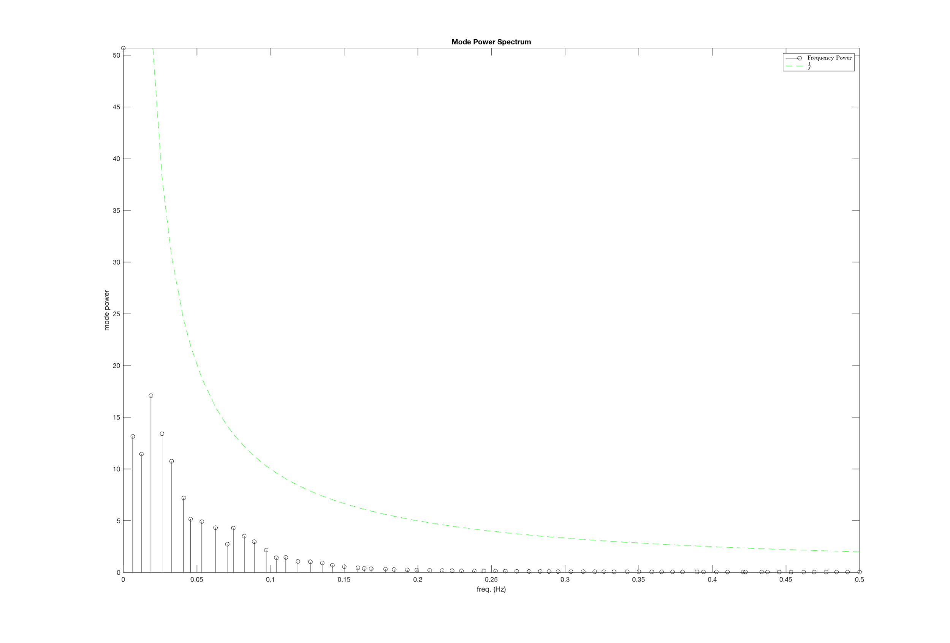

3.1.2. Mode Eigenvalues

The selected patient possesses 136 eigenvalues, of which 134 are complex conjugate pairs (67 pairs). This results in 67 unique complex conjugate pairs of eigenvalues, plus two unpaired eigenvalues corresponding to the lowest $\left(ω=0\right)$ and highest $\left(ω=π\right)$ frequencies. Of these 136 eigenvalues, only these unpaired eigenvalues are real numbers $\left(λ=1.0006\right.$ and $λ=-0.9955$ respectively). The remaining 67 complex conjugate pairs are scattered across the unit circle in the complex plane. All but three eigenvalues have magnitudes less than unity, indicating decaying oscillations. The remaining three, corresponding to the frequencies $ω=0$ $\left(f=0\right)$ and $ω=0.0654π$ $\left(f=0.0327\right)$, have magnitudes slightly above unity ( $\left|λ\right|=1.0006$ and $\left|λ\right|=1.0004$ respectively), suggesting a weak increase in amplitude over the course of the scan. It must be observed, however, that all eigenvalues lie in the vicinity of the unit circle, indicating that modes are relatively stable.

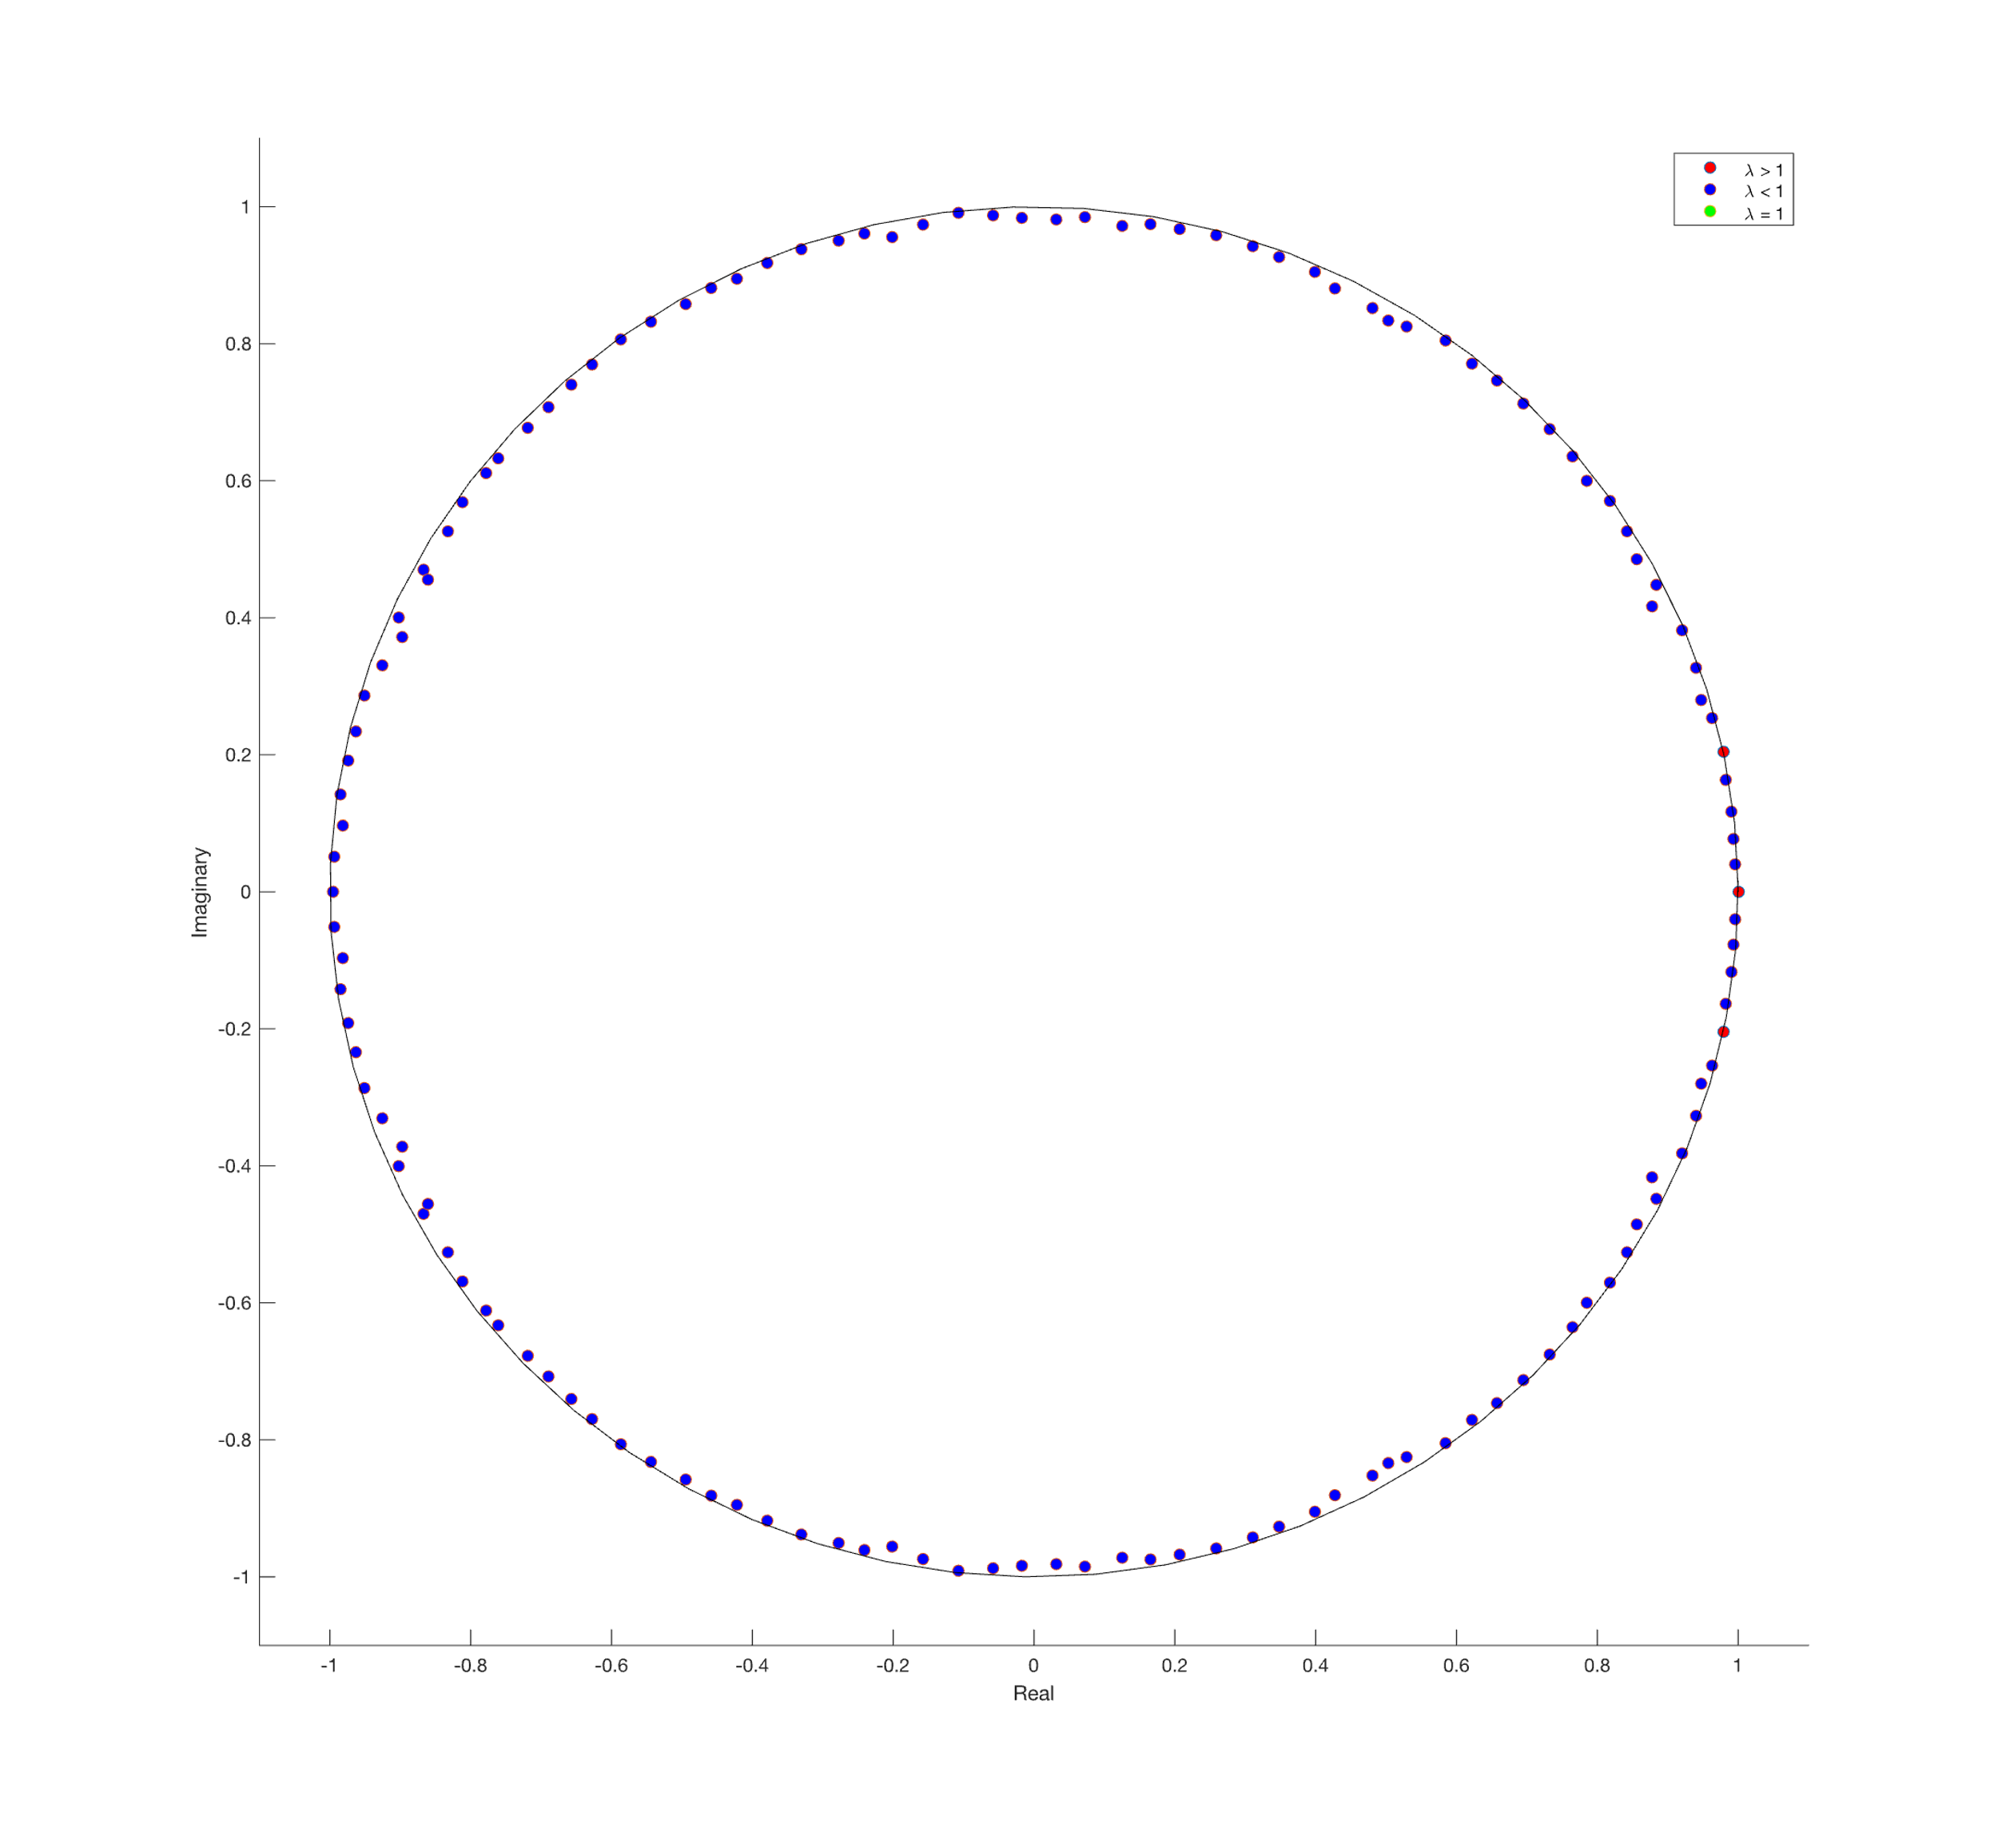

3.1.3. Mean Squared Error of the Samples

The mean squared error (MSE) per fully reconstructed sample (time point) is universally quite small $\left(O\left({10}^{-3}\right)\right)$, a fact reflected in the excellent visual agreement between original and reconstructed sFNC. However, the time-resolve MSE contains a quasiperiodic peaks-and-valleys structure that resembles a periodic function. The period is irregular, with gaps between peaks separated by anywhere from 15 to 31 time points. It may be a linear combination of functions with different frequencies, which could also explain why the last error “peak” has a gap of two samples in its center.

When only the three modes with the highest power are used for reconstruction, mean squared error increases by about a factor of 20 $\left(O\left({10}^{-2}\right)\right)$. Subtracting the partial reconstruction from the full reconstruction confirms that using three modes changes values by at most 10% over the entire connectivity map. However, this difference map displays considerable structure, suggesting that despite the contributing only a small amount of total power, higher-frequency modes contain considerable information that may be of interest to researchers. For this reason, the author recommends continued examination of higher-frequency modes, although he is not immediately certain how this might be done.

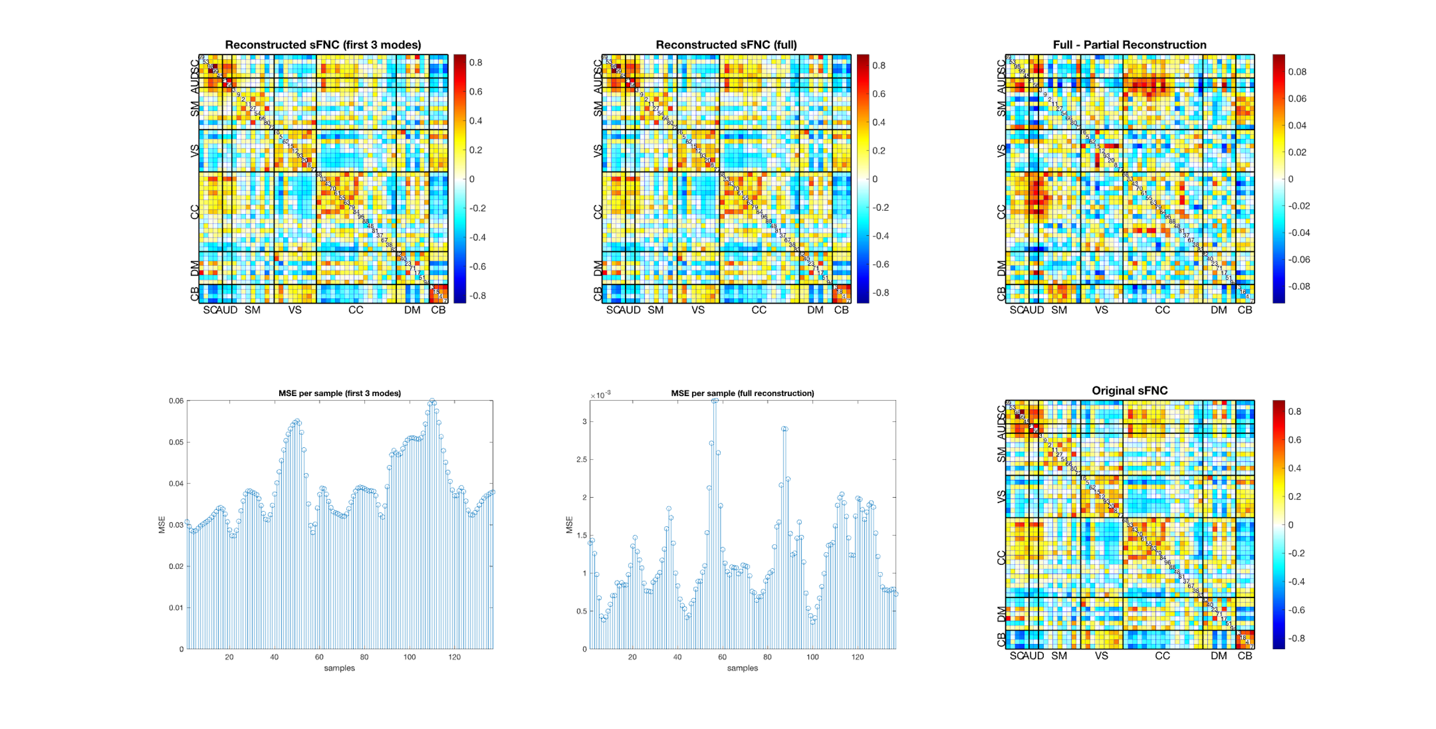

3.1.4. Functional Timecourses

To confirm the findings of eigenvalue analysis (Sec. 3.2), the author has elected to plot the time courses of the auditory cortex for the first six non-stationary modes, corresponding to the frequencies $f=\left[0.0064, 0.0123, 0.187, 0.0262, 0.0327, 0.0410\right]$. Specifically, he selected the correlation values of networks 58 and 3 with those of 53, 98, 99, and 45 (rows 6 and 7, columns 2, 3, and 4). The original FNC values for the selected patient are plotted for comparison.

The intensity of the modes corresponding to the first three frequencies show a weak exponential decay, as predicted by eigenvalue analysis. The remaining three also display decay, but this decay is not smoothly exponential. Instead, FNC value oscillations appears to display both a fast main frequency and a notably slower envelope frequency, with the envelope frequency increasing along with the main frequency. This, along with the choppy nature of some faster oscillations, may indicate an aliasing effect. Depending on the time-to-repetition, it would not be entirely surprising to find that some modes exceed the data’s Nyquist limit. The author would be surprised to find this to be the case for such low-frequency modes, but the possibility should not be ignored.

It is worth nothing that all the visualized modes display decay over the course of the scan. This is despite the fact that the original FNC values do not display an overall loss in amplitude during the scan cycle. The author must wonder about the origin of the additional power in the signal. As mode power generally declines with frequency, the additional power is unlikely to come from high frequencies. Further, one of the displayed frequencies, $f=0.0327$, had an eigenvalue greater than unity, which should indicate *increasing* power over the course of the scan. Reconstruction of this mode, however, suggests the opposite.

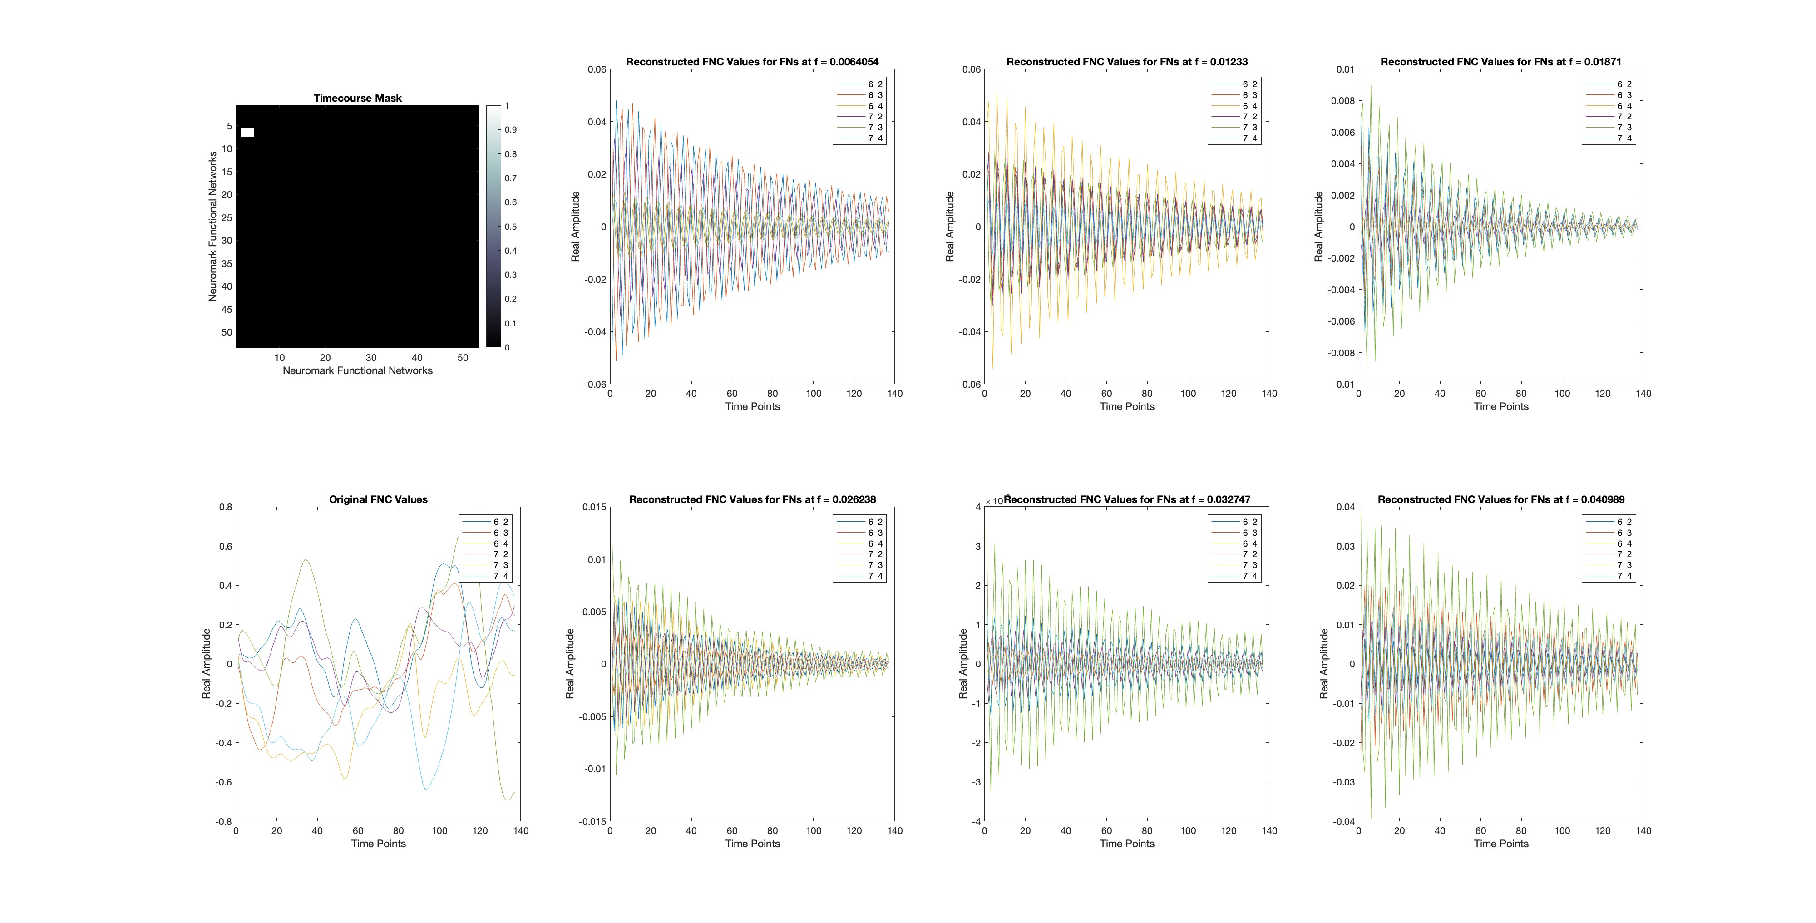

4. Next Steps

4.1. Group Distributions

Subject-level analyses will produce subject-level modes and spectra. Some means of analyzing the distributions of these modes and spectra will likely prove very useful. However, as both spectra and modes are high-dimensional variables (136 and 1378 dimensions, respectively), the multiple-comparison problem and central limit theorems may complicate the comparison of their distributions.

Comparing mode distributions may be feasible via the network-based statistic [6], [7], [8] or simple application of a multiple comparison correction to group-level differences in connectivity maps. The author recalls that several members of the group, most notably Amritha and KuaiKuai, have conducted such analyses in the past.

4.2. Large-Scale Modes and their Spectra

It may be worth comparing subject-level spectra to clinical or behavioral scores to determine whether any frequencies show links to behavioral effects. If so, an examination of the affected modes could provide useful insights into connectivity biomarkers for such behaviors. This analysis may need to account for interaction effects.